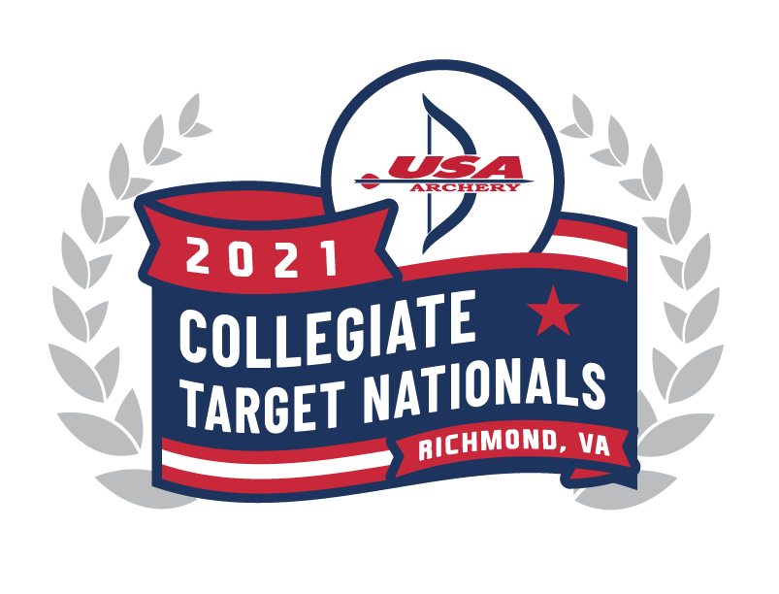
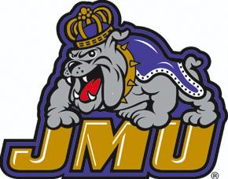

2021 USA Archery Collegiate Target Nationals &
World University Games Trials
Hosted by SVTA and the JMU Archery Team
Dorey Park, Richmond, VA
May 20-23, 2021
Schedule of Events (Tentative)*

Thursday, May 20, 2021
12:00 – 4:00pm Official Practice - Equipment & Uniform Inspection
04:15 – 4:30pm Opening Ceremonies

Friday, May 21, 2021
08:00 – 12:00pm Women’s Qualification 72 arrows - Recurve @ 70m / Compound, Bowhunter & Barebow @50m
12:00 – 01:00pm Lunch
01:00 – 05:00pm Men’s Qualification 72 arrows - Recurve @ 70m / Compound, Bowhunter & Barebow @50m

Saturday, May 22, 2021
08:00 – 12:00pm Official Practice & Ind Elim Rnd (thru Bronze Medal) Single Elimination - Rec @ 70m / Comp, B’hunter & B’bow @50m
12:00 – 01:00pm Lunch
01:00 – 05:00pm Official Team Rnd - Rec @ 70m / Comp, BH & BB @ 50m
06:00 – 08:00pm Cook-Out –Awards and Outdoor Activities – Location TBA

Sunday, May 23, 2021
08:00 – 12:00pm Mixed Team Round - Rec @ 70m / Comp, BH & BB @ 50m
12:00 – 01:00pm Lunch
01:00 – 03:00pm Gold Medal Finals - Recurve @ 70m / Comp, BH & BB @ 50m
Awards Ceremony

*Schedule is subject to change. USA Archery will be hosting the annual Collegiate Archery Program meeting virtually so teams that are unable to travel due to COVID-19 restrictions are able to hear the information and share their program questions.

