PARA ARCHERY CLASSIFICATION

PASSIVE RANGE OF MOTION TEST FOR ELIGIBILITY ASSESSMENT IN PARA ARCHERY

Name:
Date of Birth:
Country:

Bow Arm | [ ] Left  [ ] Right

Grade
0 | No range of movement
1 | Minimal range of movement
2 | 1 / 4 range of movement
3 | 1/ 2 range of movement
4 | 3 / 4 range of movement
5 | Normal, full range of movement

Shoulder | Norm | Result |  | Grade
Shoulder | Norm | Right | Left | R | L
Flexion | 0-180 | /180 | /180
Extension | 0-60 | /60 | /60
Abduction | 0-180 | /180 | /180
Adduction | 0-40 | /40 | /40
Internal rotation | 0-90 | /90 | /90
External rotation | 0-70 | /70 | /70

Elbow | Norm | Result |  | Grade
Elbow | Norm | Right | Left | R | L
Flexion | 0-150 | /150 | /150
Extension | 150/0 | 150/ | 150/
Supination | 0-80 | /80 | /80
Pronation | 0-80 | /80 | /80

Wrist | Norm | Result |  | Grade
Wrist | Norm | Right | Left | R | L
Flexion | 0-80 | /80 | /80
Extension | 0-70 | /70 | /70
Ulnar deviation | 0-30 | /30 | /30
Radial deviation | 0-20 | /20 | /20

Fingers and thumb | Norm | Result |  | Grade
Fingers and thumb | Norm | Right | Left | R | L
Flexion | 0-150 | /150 | /150
Extension | 0-40 | /40 | /40
Spread/closing | 0-180 | /180 | /180
Thumb opposition | 0-40 | /40 | /40
Thumb Extension | 0-40 | /40 | /40

Hip | Norm | Result |  | Grade
Hip | Norm | Right | Left | R | L
Flexion 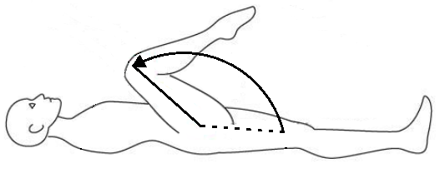 | 0-120 | /120 | /120
Extension 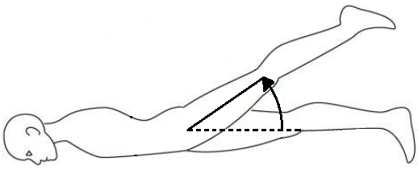 | 0-30 | /30 | /30
Abduction 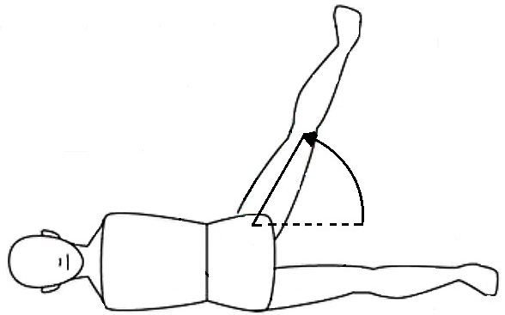 | 0-45 | /45 | /45
Adduction 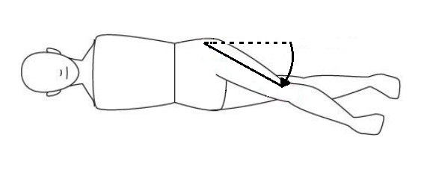 | 0-30 | /30 | /30
Internal rotation 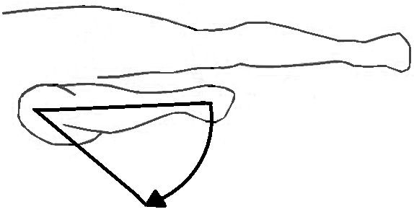 | 0-45 | /45 | /45
External rotation 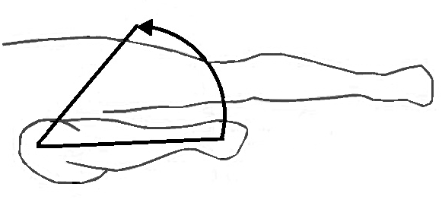 | 0-45 | /45 | /45

Knee | Norm | Result
Knee | Norm | Right | Left
Flexion 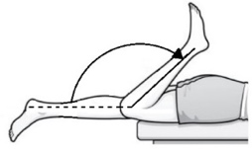 | 0-140 | /140 | /140
Extension 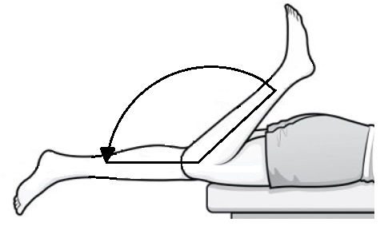 | 0 | /0 | /0

Ankle | Norm | Result
Ankle | Norm | Right | Left
Plantarflexion 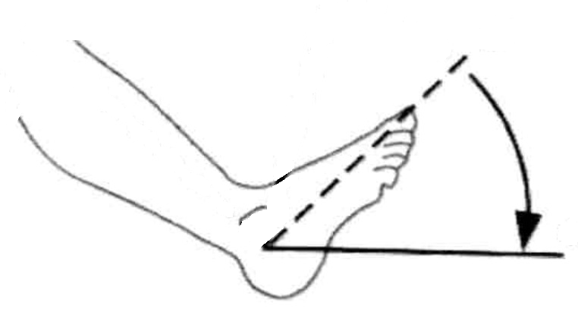 | 0-50 | /50 | /50
Dorsiflexion 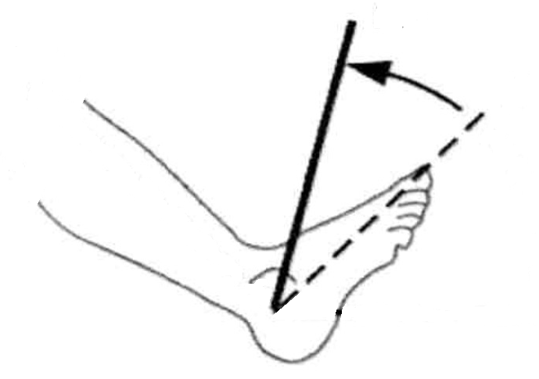 | 0-20 | /20 | /20

Date:

Medical practitioner name and title:

Medical practitioner signature:

