PARA ARCHERY CLASSIFICATION

SARA SCALE FOR ELIGIBILITY ASSESSMENT IN PARA ARCHERY

Name:
Date of birth:
Country:

SARA Scale – Heel-shin slide
Lying supine, the athlete lifts one leg, places heel on opposite knee, slides down along the shin to the ankle, lays the leg back down and repeats the movement 3 times. Slide-down movements should be performed within 1 second.
Grade | Description
0 | Normal
1 | Slightly abnormal, contact to shin maintained
2 | Clearly abnormal, goes off shin up to 3 times during 3 cycles
3 | Severely abnormal, goes off shin 4 or more times during 3 cycles
4 | Unable to perform the task

Task | Result
Task | Left | Right
Heel-shin slide 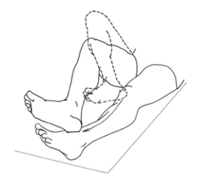 | /4 | /4

SARA Scale – Stance
The subject stands bare feet with eyes open in (1) natural position, (2) with feet together in parallel (big toes touching each other) and (3) in tandem (both feet on one line, no space between heel and toe). For each position, three trials are allowed. Best trial is rated (max 10 seconds).
Grade | Description
0 | Normal, able to stand in tandem for > 10 s
1 | Able to stand with feet together without sway, but not in tandem for > 10s
2 | Able to stand with feet together for > 10 s, but only with sway
3 | Able to stand for > 10 s without support in natural position, but not feet together
4 | Able to stand for >10 s in natural position only with intermittent support
5 | Able to stand >10 s in natural position only with constant support of one arm
6 | Unable to stand for >10 s even with constant support of one arm

Task | Result
Natural stance 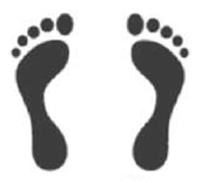 | /6
Feet together 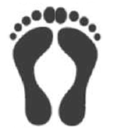 | /6
Tandem 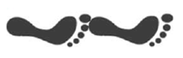 | /6

SARA Scale – Gait
The subject (1) walks at a safe distance parallel to a wall a minimum of 10 meters, turns around to face the opposite direction and (2) walks in tandem (heel to toe) a minimum of 10 steps.
Grade | Description
0 | Normal, no difficulties in walking, turning and walking tandem (up to one misstep allowed)
1 | Slight difficulties, only visible when walking 10 consecutive steps in tandem
2 | Clearly abnormal, tandem walking >10 steps not possible
3 | Considerable staggering, difficulties in half-turn, but without support
4 | Marked staggering, intermittent support of the wall required
5 | Severe staggering, permanent support of one stick or light support by one arm required
6 | Walking > 10 m only with strong support (two special sticks or stroller or accompanying person)
7 | Walking < 10 m only with strong support (two special sticks or stroller or accompanying person)

Task | Result
Gait 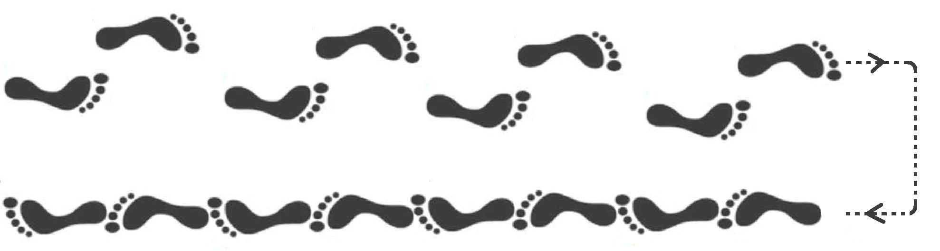 | /7

SARA Scale – Finger chase test
The athlete sits (with trunk and foot support if needed) The examiner moves their finger in unpredictable directions at must quickly follow the examiner’s finger using their own index finger ∼30 cm distance in front of the athlete (approx. every 2 seconds). The athlete must quickly follow the examiner’s finger using their own index finger
Grade | Description
0 | No dysmetria
1 | Dysmetria, under/ overshooting target <5 cm
2 | Dysmetria, under/ overshooting target < 15 cm
3 | Dysmetria, under/ overshooting target > 15 cm
4 | Unable to perform 5 pointing movements

Task | Result
Task | Left | Right
Finger chase test | /4 | /4

SARA Scale – Nose-finger test
The athlete sists and repeatedly touches their own nose and then the examiner’s finger, which is held ad about 90% of the athlete’s full arm reach. Assessments are performed bilaterally, and the mean values are used to obtain the total score
Grade | Description
0 | No tremor
1 | Tremor with an amplitude < 2 cm
2 | Tremor with an amplitude < 5 cm
3 | Tremor with an amplitude > 5 cm
4 | Unable to perform 5 pointing movements

Task | Result
Task | Left | Right
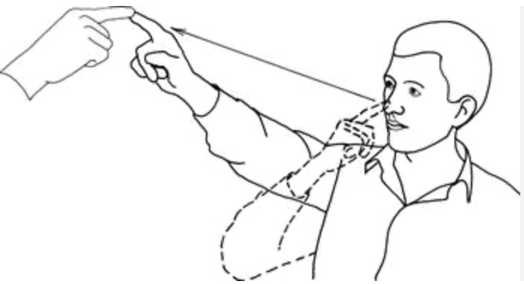 | /4 | /4

SARA Scale – Fast alternating hand movements
Assessments are performed bilaterally, and the mean values are used to obtain the total score
Grade | Description
0 | Normal, no irregularities (performs <10s)
1 | Slightly irregular (performs <10s)
2 | Clearly irregular, single movements difficult
3 | Very irregular, single movements difficult to distinguish or relevant interruptions, performs >10s
4 | Unable to complete 10 cycles

Task | Result
Task | Left | Right
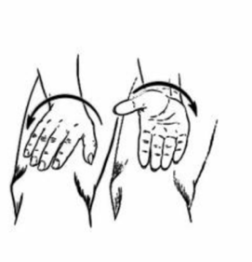  Fast alternating hand movements | /4 | /4

 |  | left | right | Average score left/right | Total (sum of scores)
Finger chase test |  | …./4 | …./4 | …./4
Nose-finger test |  | …./4 | …./4 | …./4
Fast alternating hand movements |  | …./4 | …./4 | …./4
 |  |  |  |  | …./12

Heel-shin slide |  | …./4 | …./4 | …./4
Gait | …./8
Stance | …./6
 |  |  |  |  | …./18

Sitting | …./4

FINGER CHASE | https://youtu.be/ZuiONqmDQSs?si=dQwsYR-5B-x4V6DJ
FAST ALTERNATING HAND MOVEMENT | https://youtu.be/cm5tl1NPSUU?si=xvyEgD8I5kSfxo8g
NOSE FINGER TEST | https://youtu.be/JcEOyb6ours?si=1QdGDWV98Y1b2kLd
GAIT | https://youtu.be/yaSL8sQzO4M?si=dNNf8Cb2sz6m4lf9
HELL SHIN SLIDE | https://youtu.be/OjqjpH8yAIU?si=9EeKMftIPU-dOcsl
STANCE | https://youtu.be/YD8QjUzYyag?si=evEes1s0AMrN_1VE
SITTING | https://youtu.be/ggC_gGjwNFg?si=hWjGNmKcxLPuzm-Z

Date:

Medical practitioner name and title:

Medical practitioner signature:

